OCHR FactSheet

**THE**

Defense Senior Leader Development Program

Audience: DON Workforce

Issued: Jun 2018

Senior Leaders

**Background**

The Defense Senior Leader Development Program (DSLDP) is the premier civilian leader development program. DSLDP institutes a competency-based approach to the deliberate development of senior civilian leaders with the enterprise-wide perspective needed to lead organizations and programs, and achieve results in the joint, interagency, and multi-national environments.

**Eligibility requirements**

Permanent full-time Department of the Navy (DON) Civilian employees who are already leading high performing organizations and programs and have the potential and motivation to take on even more responsible senior leadership positions. GS-14-15 or equivalent with at least 1 year of recent supervisory experience are eligible to apply.

​**Program attributes**

Managers and supervisors will gain additional skills and competencies needed to excel in the 21st Century joint, interagency, and multi-national environments. Participants will learn how to foster interagency cooperation and information sharing methodologies that will prepare them to sense and respond to the issues and challenges facing leaders across DoD and the broader national security arena.

**Length of program**

This program is two years in length and during this time participants will attend Orientation, Seminar 1, an online prerequisite course, attend PME School, participate in an experiential assignment, Seminar 2, Seminar 3, then graduate from the program.

**How to apply**

Applicants must complete the following: DSLDP Nominee Information Sheet, Resume, three Performance Appraisals, Current SF-50, Narrative Statement of Achievement (ECQs), Statement of Interest, Supervisor’s Assessment and Narrative, and Transcripts for baccalaureate or graduate degree.

This Fact Sheet:

* Provides helpful information and tips on how to apply for this leadership program
* Answers frequently asked questions

**NOTE:** Applicants are advised to check with their Command Training Representative for information regarding internal deadline dates and any additional requirements. Command endorsed packages must be submitted via the Portal Electronic Submission Process.

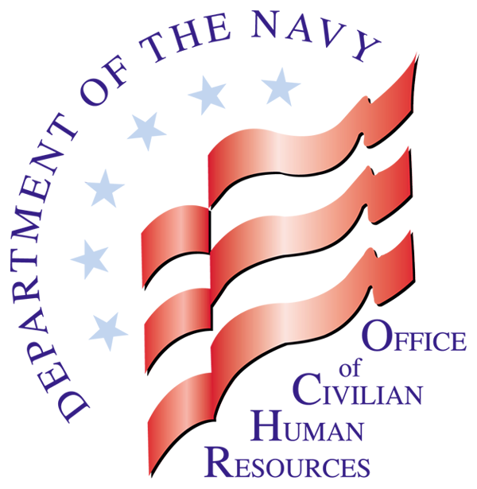

**OCHR**

**FactSheet**

Department of the Navy

Civilian Careers

Where Purpose and Patriotism Unite

**FactSheet: Defense Senior Leader Development Program** ***Issued: Jun 2018***

Frequently Asked Questions

Q. What leadership competencies does this program address?

A. Lead Organizations and Programs

Q. What is the cost of this training?

A. DSLDP tuition is centrally funded by the Defense Civilian Personnel Advisory Service (DCPAS) and travel requirements for DSLDP participants are funded by the commands.

Q. What are the dates of the course?

A. Participants will be away at PME School for ten consecutive months plus any additional training that has been identified on your Individual Development Plan, seminars, etc.

Where to Find Additional Information

Additional information regarding leadership programs can be found on the DON CHR website at https://portal.secnav.navy.mil/orgs/MRA/DONHR/Training/Pages/DSLDP.aspx. This website provides:

DSLDP Application Package

DSLDP Program Overview

Additional answers to frequently asked questions

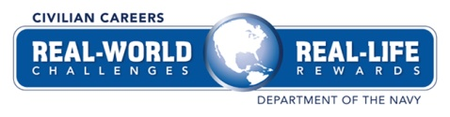



**OCHR**

**FactSheet**

Still Need Assistance?

For additional information about the Defense Senior Leader Development Program, email the Civilian Workforce Development Division at [CWDD@navy.mil](mailto:CWDD@navy.mil).